WATS UP
CONFERENCE

Sundsvall 16.08-18.08.2023

CONTACT PERSONS:
Prof. Lena Boström
Lena.bostrom@miun.se
A/Prof Marcia Håkansson Lindqvist
Marcia.hakanssonlindqvist@miun.se.
CAMPUS MAP
SUNDSVALL

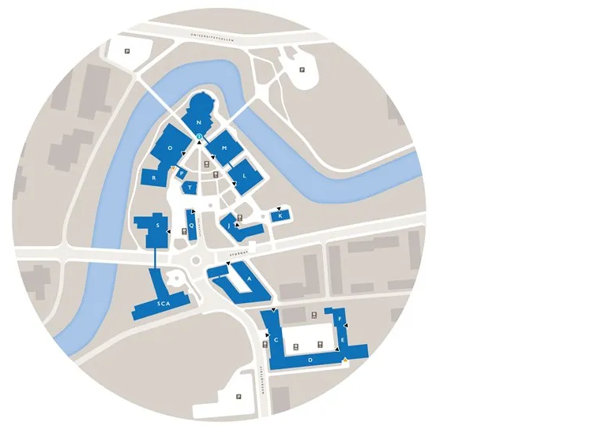

ADDRESS:
Mittuniversitetet
Holmgatan
85230 Sundsvall, Sweden
MEETING SCHEDULE
Day 1 – August 16th, 2023
09:00 am introduction (update on research)
10:30 am comparing teacher shortage in DEN, GER, SWE
12:00 am break
01:00 pm next application
02:00 pm break
02:30 pm workshop – reflecting our research
05:00 pm departure for Härnösand

Day 2 – August 17th, 2023
09:00 am preparing the poster session
10:00 am break
10:30 am meeting Anna Ekström (former minister of higher education)
01:00 pm start of public session
until 02:40 pm welcome, keynote by Anna Ekström
until 03:00 pm break and poster discussion
until 03:30 pm presentation and discussion (DEN)
until 04:00 pm presentation and discussion (GER)
until 04:30 pm presentation and discussion (SWE)
until 05:00 pm conclusion and discussion
05:00 pm end of public session
06:00 pm guided walk (North Mountain)

Day 3 – August 18th, 2023
09:00 am reflection on public session
10:00 am discussion on gender articles
11:00 am conclusions on solutions to teacher shortage
12:00 am next conference
01:00 pm closing and depature

