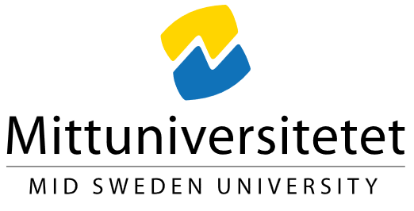
Information for participants and consent
(Student work at Mid Sweden University)

1. Information about student work
Title of student work: [Enter the title of the student work]
Course/programme and institution: [Specify course/programme and institution]
Responsible student: [Name, email, phone]
Supervisor/course coordinator: [Name, email ]

2. What kind of student work is it and why are you being asked?
Purpose of student work: [Describe brief background and purpose of student work]
Why are you being asked? [Please explain why this particular person is being asked and how contact details have been obtained.]

3. How does the student work?
[Describe what participation means (interview, survey, observation, etc.), time and number of occasions. Indicate whether the interview is recorded and how the material is handled.]

4. Possible consequences and risks of participation
[Describe any risks or discomforts (e.g. emotional reactions, privacy risks). If there are no specific risks, please indicate: Participation is not deemed to present any particular risk or discomfort.]

5. How do you get information about the result?
[Describe how the participant can access the completed thesis or the result.]

6. Your participation is voluntary
Your participation is voluntary. You can cancel at any time without giving reasons. If you withdraw your consent, the data may no longer be used or stored.

Processing of personal data

7. What personal data are processed?
The personal data that may be processed within the framework of the student work are:
- [Insert types of personal data, e.g. name, contact details, interview responses, survey responses, audio recordings, etc.]
The data can be directly or indirectly linked to you and therefore constitute personal data according to the EU General Data Protection Regulation (GDPR).

3. Why is the personal data processed?
The personal data is processed in order to carry out the student work and fulfil its purpose.

4. Controller
Mid Sweden University is the data controller for the processing of your personal data.
Contact details:
Mid Sweden University
851 70 Sundsvall
E-mail: registrator@miun.se
Telephone: 010-142 80 00
Mid Sweden University has appointed a data protection officer who can be reached at:
dataprotection@miun.se

5. Legal basis for the processing
The legal basis for the processing of personal data is your consent pursuant to Article 6(1)(a) GDPR. You give your consent by signing this document.

6. How long the personal data is processed
The personal data will be processed for the duration of the student work, which is estimated to last until:
- [Enter end date or time period]
When the work has been examined and the grades have been reported, the documentation is deleted or thinned.

7. How personal data is protected and who can access it
Your personal data is processed securely and protected against unauthorised access. Only the responsible student and authorised staff at Mid Sweden University have access to the data.

8. Your rights
According to the General Data Protection Regulation, you have the right to:
- request access to your personal data (register extract)
- request rectification of inaccurate data
- request the erasure of your personal data
- request restriction of processing
- receive your personal data (data portability)
- object to the processing
You also have the right to withdraw your consent at any time. However, a withdrawal does not affect the lawfulness of the processing that took place before the consent was withdrawn.
To exercise your rights, you can contact the head of student work or the data protection officer at Mid Sweden University at dataskyddombud@miun.se.

9. Complaints
If you believe that your personal data is being processed incorrectly, you have the right to lodge a complaint with the supervisory authority:
Privacy Protection Authority (IMY)
Website: imy.se

10. Additional information
More information about how Mid Sweden University processes personal data can be found on the web:
Processing of personal data | miun.se

Consent
I have read the information above and agree to participate in the student work and to my personal data being processed as described.
☐ Yes, I agree
Date: ____________________________
Name: ____________________________
Signature: ____________________________

This template has been developed for student projects at Mid Sweden University where consent is the legal basis for personal data processing.

